VISION OPERATION

ESTABLISH TEMPLATE SYSTEM

MARITIME COMMERCIAL JOINT STOCK BANK

Hanoi, 01-2015

TABLE OF CONTENTS

A. INTRODUCTION 3

B. OVERVIEW OF VISION SYSTEM 4

I. DATA PROCESSING MODEL 4
II. DAILY JOB 4

II.1 Data changed within a day <Daily Job> 4

I.1 Information processing flow 7
I.2 Balance processing flow 7
I.3 Backdated/Valudated processing flow 8
2.3.3. Daily batch flow when trouble occurs 9
2.3.4. Batch month flow when trouble occurs. 9

Introduction

Terms | Explanation
FTP | Fund Transfer Pricing
PE | End Of Period Balance

This document briefs about backend operations neceasary to monitor on daily basis and troubleshoot.

Overview of Vision system

I.data processing model
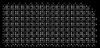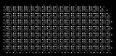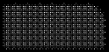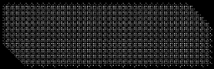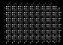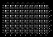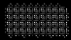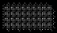
SOURCES
Core Bank
Kondor
Way
4
Others
(
DWH
,
Line
,
CSS
)
Manual Input
(
Web Application
)
ETL
Datamart Layer
Financial Daily
Financial Monthly
Financial History
Static data
MIS Results
Cognos
Vision
System
Parameters
Report
RAW Layer
DD
CD
LN
OD
TF
GL
CC
MM
PLN
&
TLDP
BOND
REPO
FX
Option
Future
Paper
Static Data
Branch
Product
Currency
Country
Folders
?
.
Limit
Collateral
...
- Describe the data source components
- Rawlayer consists for 17 major feed_staging tables as described in ETL mapping document. These tables have transformed source information on daily basis to build Vision data.
- Datamart majorly consist of financial and non financial sets of tables. Financial tables has entire trial balance for each day along with summerized account balances. While non financial information consists for cutomer/account/contractual details.
- Reports are standard procedures that query from datamart based on parameters.

Daily job
To build a daily data in Vision, we need following extract from staging.
The details of Data classification are as follows:

II.1 Data changed within a day <Daily Job>
Information changed daily including:
- Information about system parameters:
  - Customer static data
  - Accounts static data
  - Non financial, Contract Information
  - Financial data (LN,CD,DD,TF…)
  - Exchange rates
  - …
These data tables will be analyzed and evaluated to determine the change in information compared to previous day and which one to be effective on the following day .
Customer information:
  - Adding new customers.
  - Customers, who change their information: Name, addresss, relationship, …
- DD account information.
  - New opened account
  - The account status
  - Account balance/ Interest
- CD account information
  - New opened account
  - Principal balance/ Interest
- LN account information
  - New opened account
  - Principal balance/ Interest
- Information on credit contracts
- Information on collateral
- Transaction on ALL account
Cron scheduler is scheduled in crontab to initiate daily job.
Daily job checks for following check conditions.
- STAGING_ALL_FINISH status from CSTB_ETL_LOG.
- Pending EOD Aborts from previous day
If conditions are valid, EOD job is initated to extract using package from source staging.
ETL status various module can be monitored in Vision_feed_controls_loop.

Data processsing model
Base on the classification of frequency of change for information types, we have the data processing model as follows

Components in daily data processing flow <batch Daily>

Information processing flow
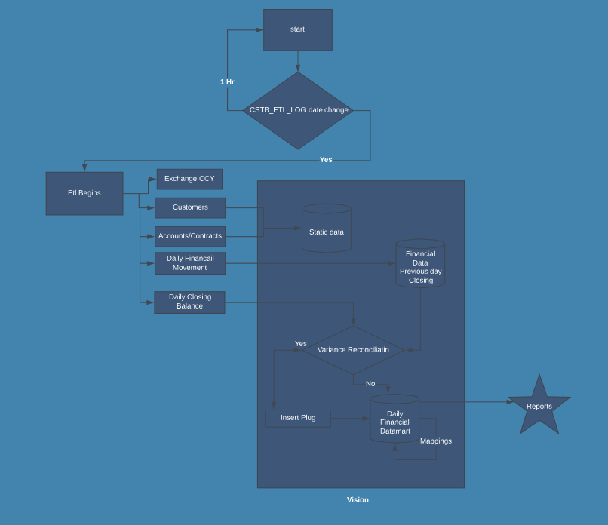

The table of changed static data and Financial movement will be recognized and extracted in ETL. This ETL Job will call a package for processing Data processing flow running Batch Month

Balance processing flow
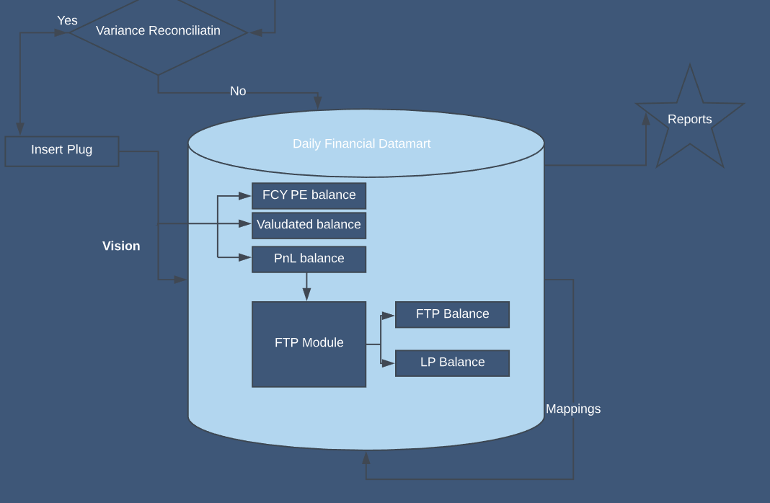

After Reconciliation, balances flow into vision in FCY for PE and LCY equivalent for PnL.
FTP module then Computes daily FTP and LP upon account balances based on derived PE balance for the day.

3.Backdated/Valudated processing flow

Vision recogonises back value dated transaction upto prior month. Vision fetches backdated movement in combination of GL,currency,branch and account to append movement for effective date.

Operating Instructions
Run Daily Job

- This is to run daily EOD process in Vision. EOD is automatically trigged as mentioned in 2.2.1.
- To trigger manually, call the shell script (.sh) mentioned in Vision user Crontab.
- Vision_feed_controls_loop table will show will update completed flag as and when each feed is completed.
- Builds will automatically initiate after completion of daily extraction to start Vision EOD process.
- To trigger manually, follow below screenshots
- Builds to trigger are auto checked under DLYFEEDS Major build.
- Job diagram

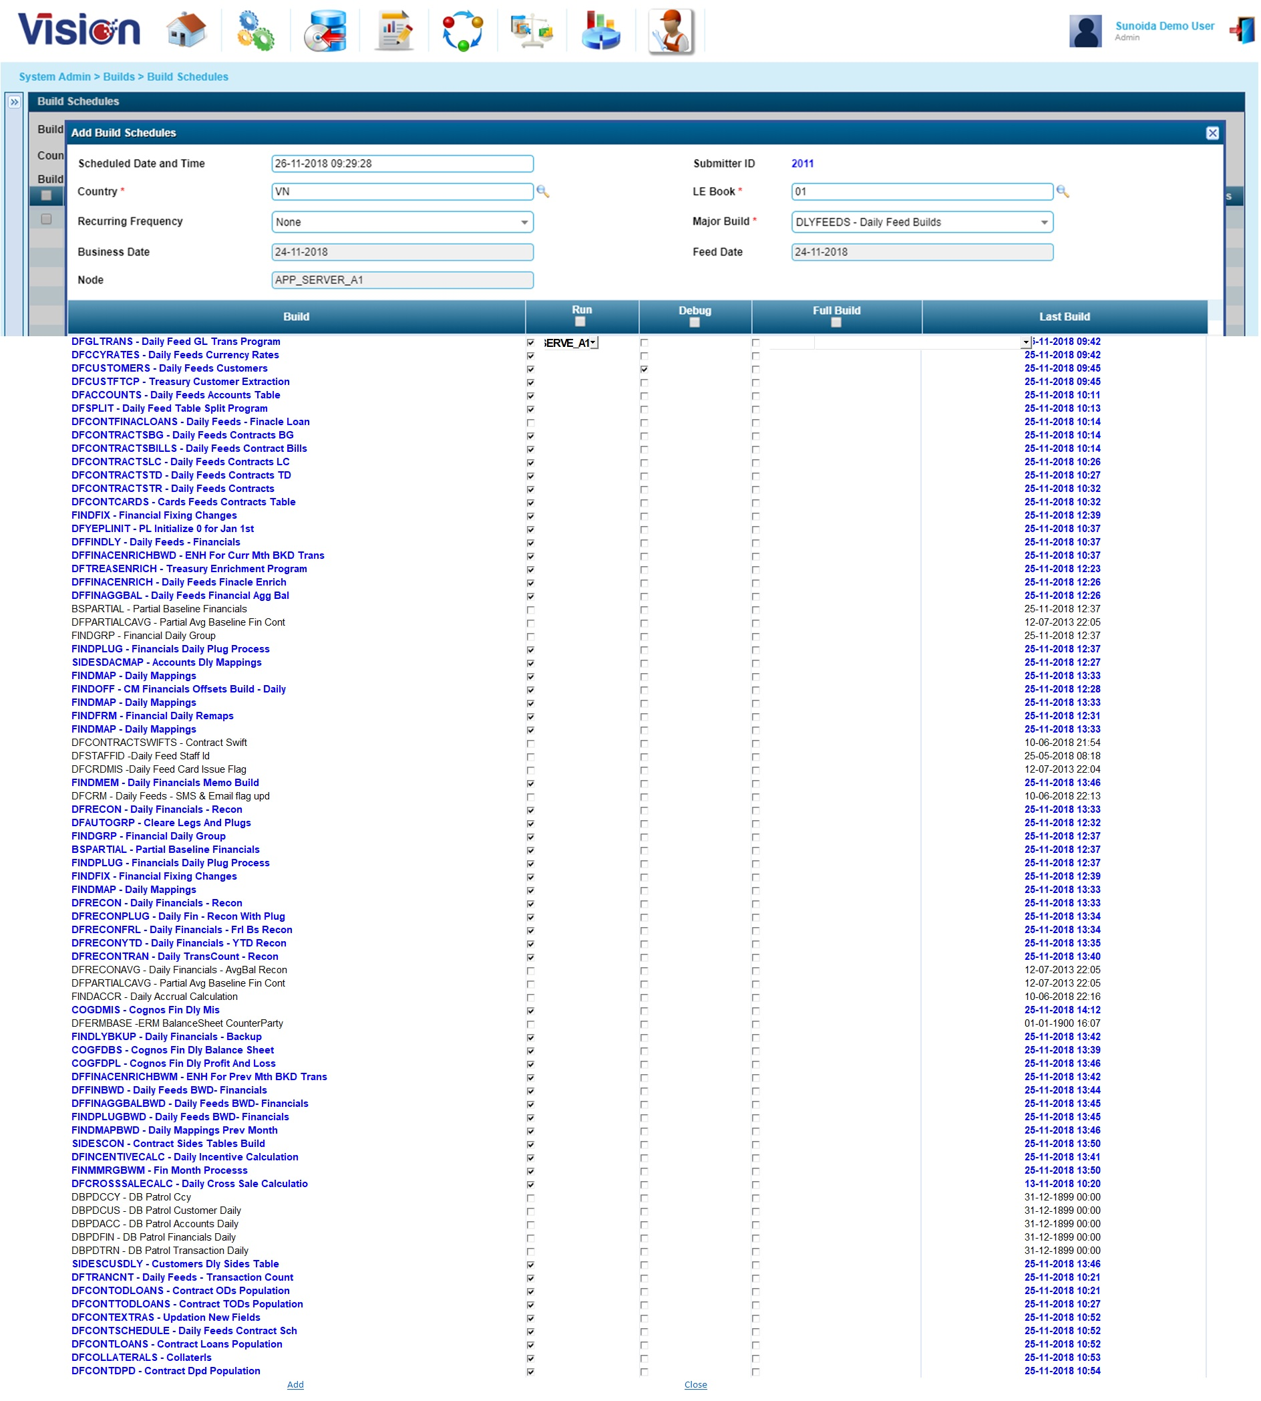

- Description of running condition

BUSINESS_DATE under Vision_business_day has to be EOD date. Which updates automatically after ETL extraction.

- Check Build logs from interface program and Unix Server

From front end application, we can download the error file. Please clictk error log button to see error file from below screen shot.

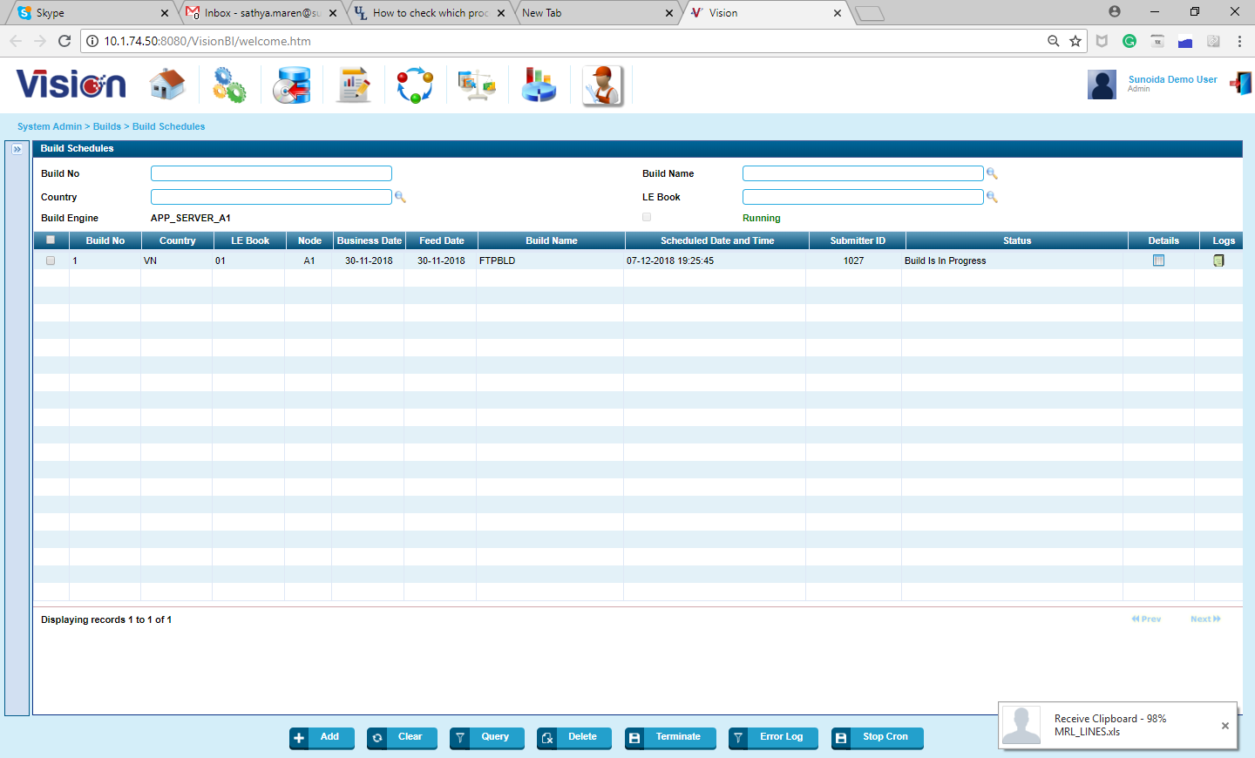

Error log button shows log file. And download log files for specific date.

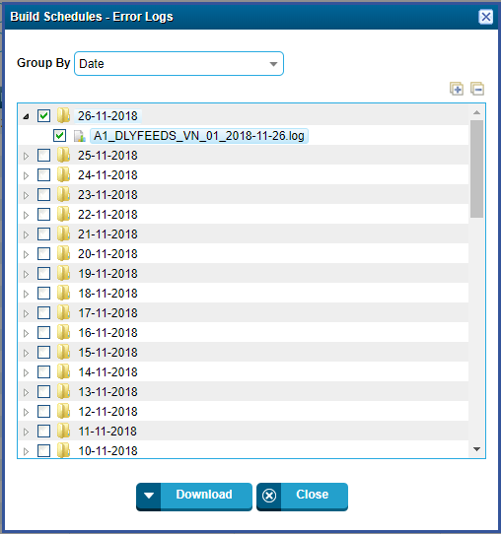
From unix we can see the error file from below folders

/home/vision/buildlogs/<Filename>

- BuildCron Engine
Cron engine can stop due to network connectivity between app server and Database.
If app server /DB restarts, Cron Engine has to be reinitiated

To check Cronstatus, run Shell script Cronstatus.sh .

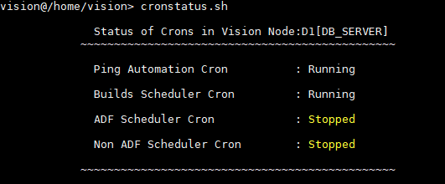

- To stop a running build engine,

Call shell, stopcron.sh. This script will automatically kill all running build Jobs from proceeding further.

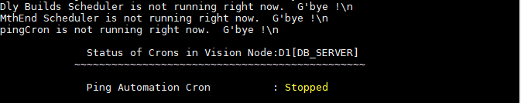

- To Start Build engine.

Call shell, runcron.sh. This script will automatically start build engine and initate builds to proceed further.

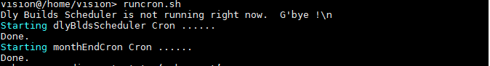

  - Run monthly Job
- Description of condition for running
Vision_business_day must be monthend date. EOD for new month cannot proceed without EOM Rollover process as it affects opening balance for the following month.

- Initate Monthend Job in 2 steps
- Step: 1
This will update Current month status and prepare Vision for Rollover.
Note: Month end should be finished before 1st day CBS EOD of next month.
CMROLL – It is the major build, under which we need to run all the default builds.
- Run - Country ZZ and LE_BOOK 99
- CMINIT – It will initiate the Current Month and Current Year in the vision variable table and truncate the month end tables.
- FRSET – this build initiate the financial remaps status.
- This major build should run on month end.

- select * from VISION_VARIABLES where variable ='CURRENT_MONTH'
- select * from VISION_VARIABLES where variable ='CURRENT_YEAR'

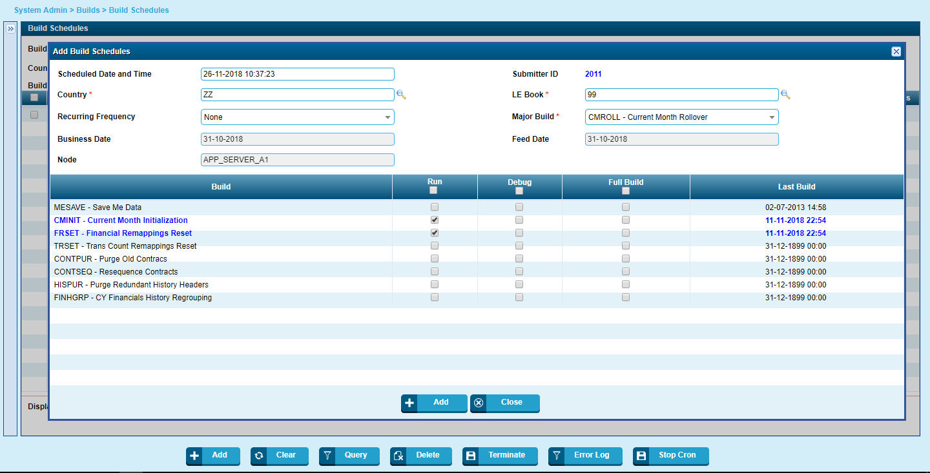
- Step: 2

After Completion of Step 1,

Initate MONTHENDBLDS major build.

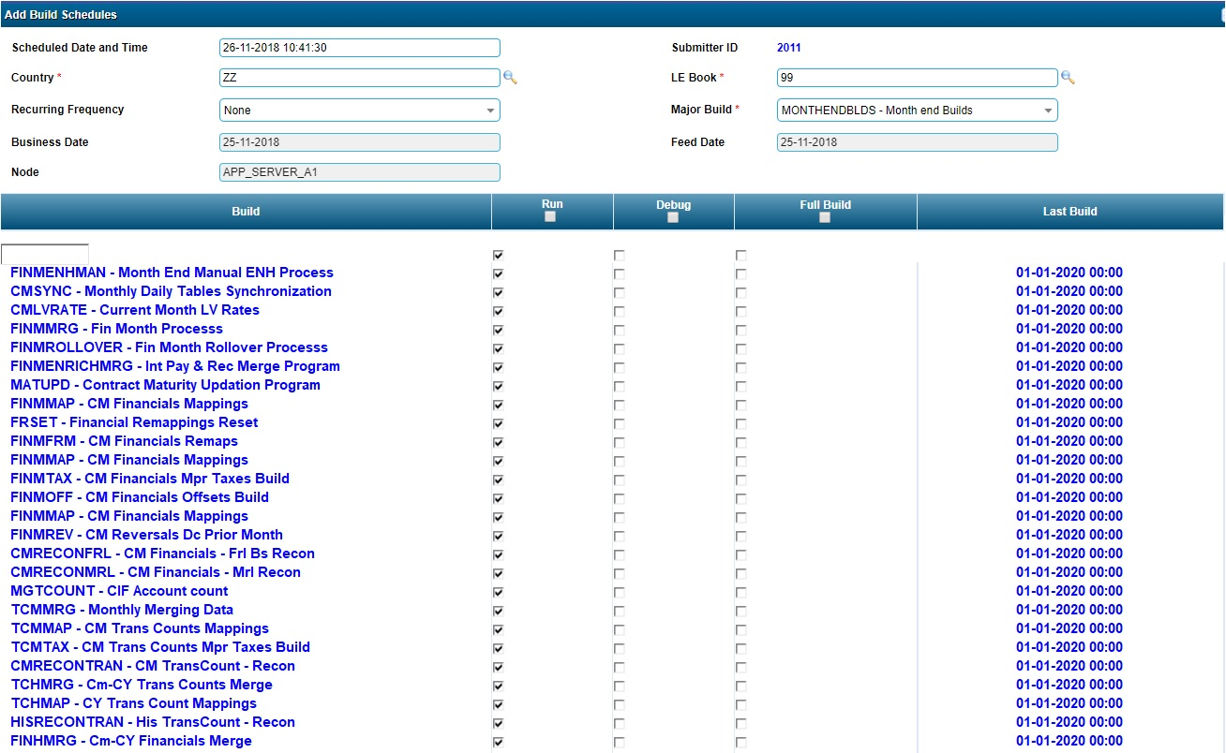

  - Recalculate FTP after Monthend
If Monthend has already been run, then initiate Major build FTPBLD major build for Country ZZ and LE_BOOK 99

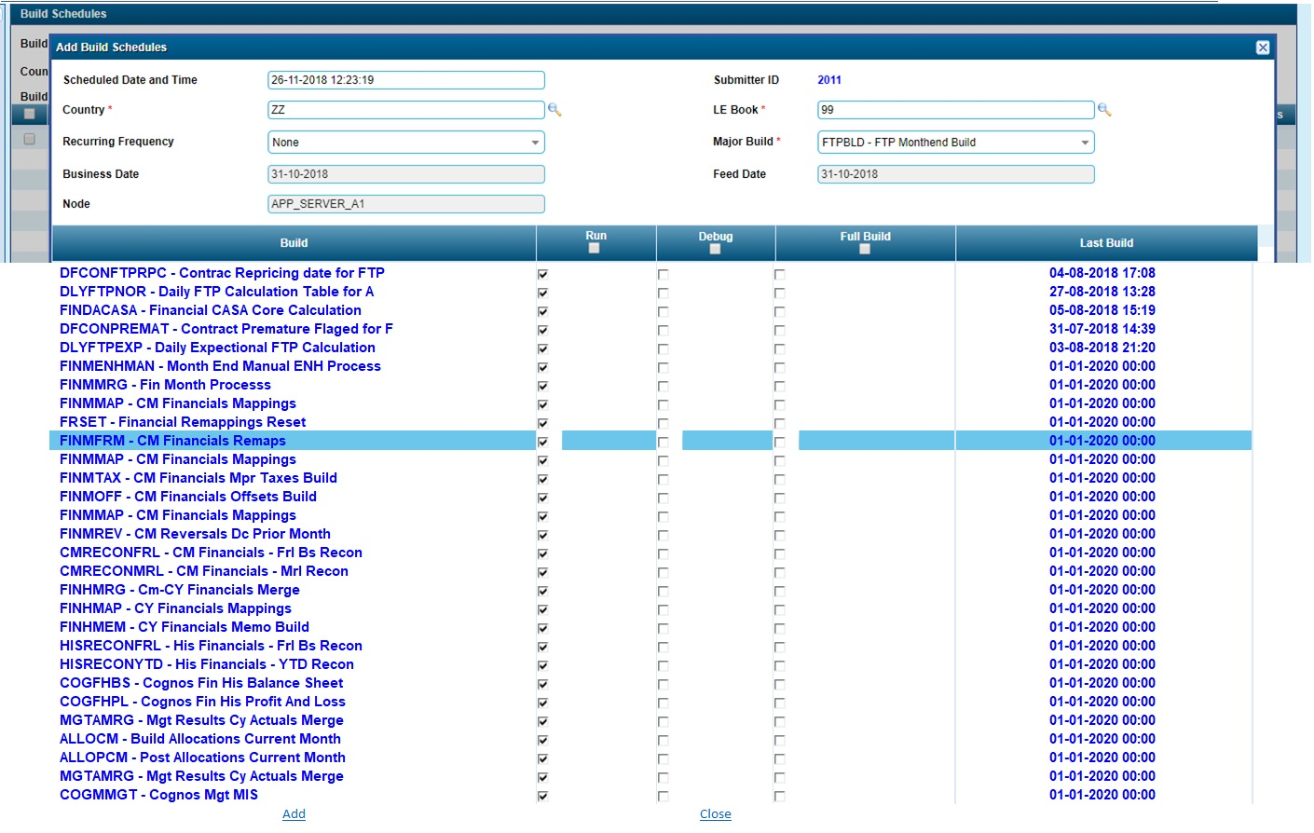

  - Rrerun Financial Adjustments

To pass approved adjustments into vision, Run major build ADJUSTMENTBLDS build as per screenshot below.

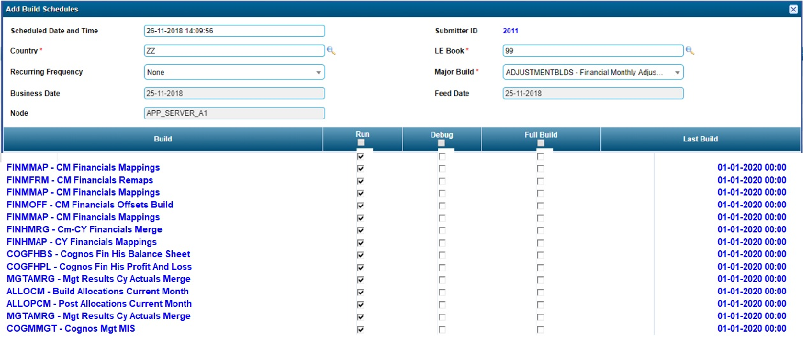

  - Rrerun daily Job
Similar to 3.1 or connect to Vision Support
  - Rerun month Job
Similar to 3.2 or connect to Vision Support

- Common errors and troubleshooting
- Plug

Vision extracts daily movements and adds it to previous day closing balance. To reconcile, Vision compares data against ERP GL closing balance.

If variance exists, Vision automatically creates plug balance to bridge the gap.

Run Vision Plug transaction report everyday to check for Variance.

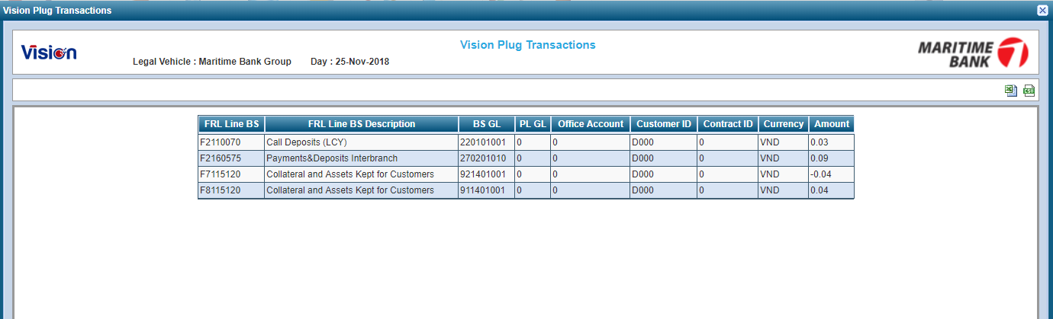

- Trouble shooting Plug Variance.
If variance is in balance sheet GL, Vision can automatically fix the variance by running following build programs

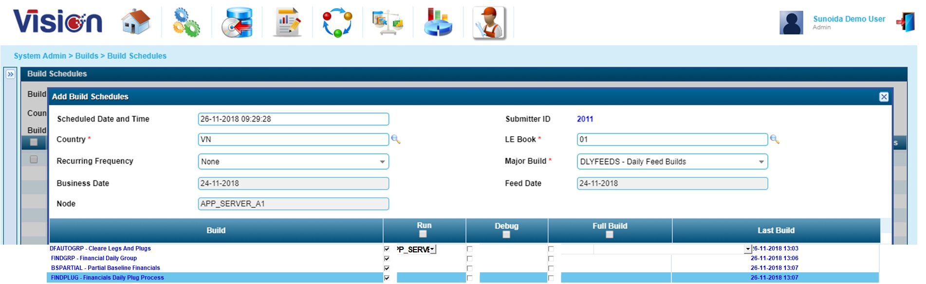

If variance is in PnL GL, Please contact Vision support.

- Variance due to unmapped GLs

Run the following report, If any unmapped GLs, excalate to finance team.

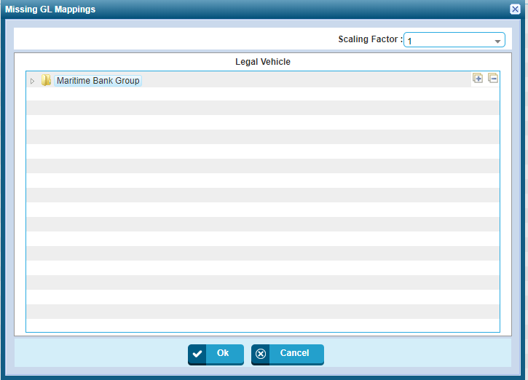

- Builds to Run after mapping

There could be several reasons to rerun mappings
- New GL
- Changing Mappings /Remap GL to a new line.
- Rename description/Add/Invalid Mappings.

If Finance maintained the new GL's it's not informed to vision, then DFGLTRANS build will abort an its display the news GL's lists. You need to maintain the new GL's in GL codes table and GL mappings. Before maintaining please cross verify with Finance.

- Changes MRL / FRL , OUC / Product – Finance Team
If you or Finance team has changed any MRL, FRL, OUC and Product, we need to run the below build. Either you can run or inform to DBA team (IT Team)
- SIDES - SIDESFRL country ZZ and le_book 99 for if FRL changes
- SIDES - SIDESMRL country ZZ and le_book 99 for if MRL changes
- SIDES - SIDESOUC country ZZ and le_book 99 for if OUC changes
- SIDES - SIDESPRD country ZZ and le_book 99 for if Product changes.
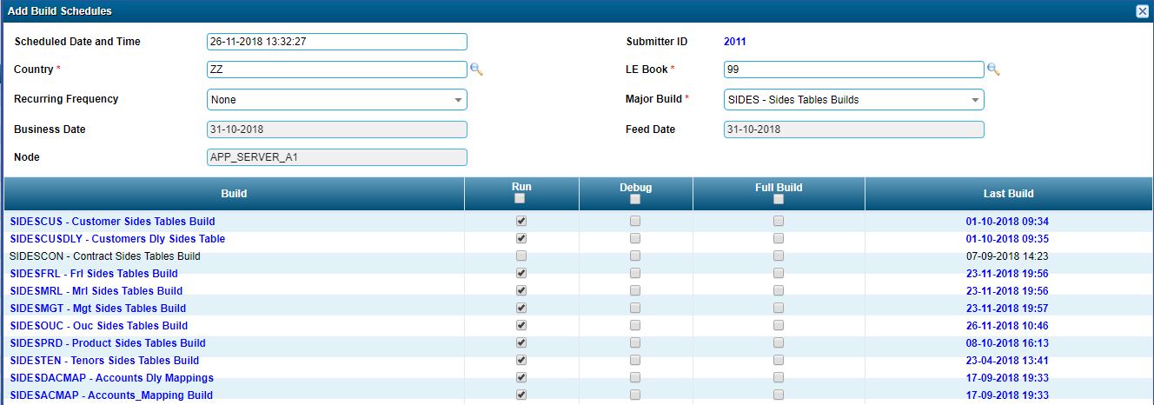
- Changing Mappings – Finance Team
If GL Mappings changes have been made then we need to run the below builds country wise VN 01.
- FINDBLD – FINDMAP

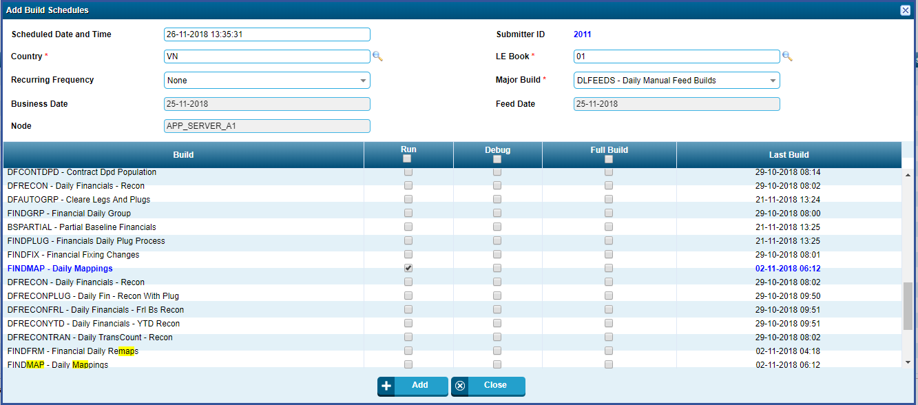

- FINMBLD – FINMAP

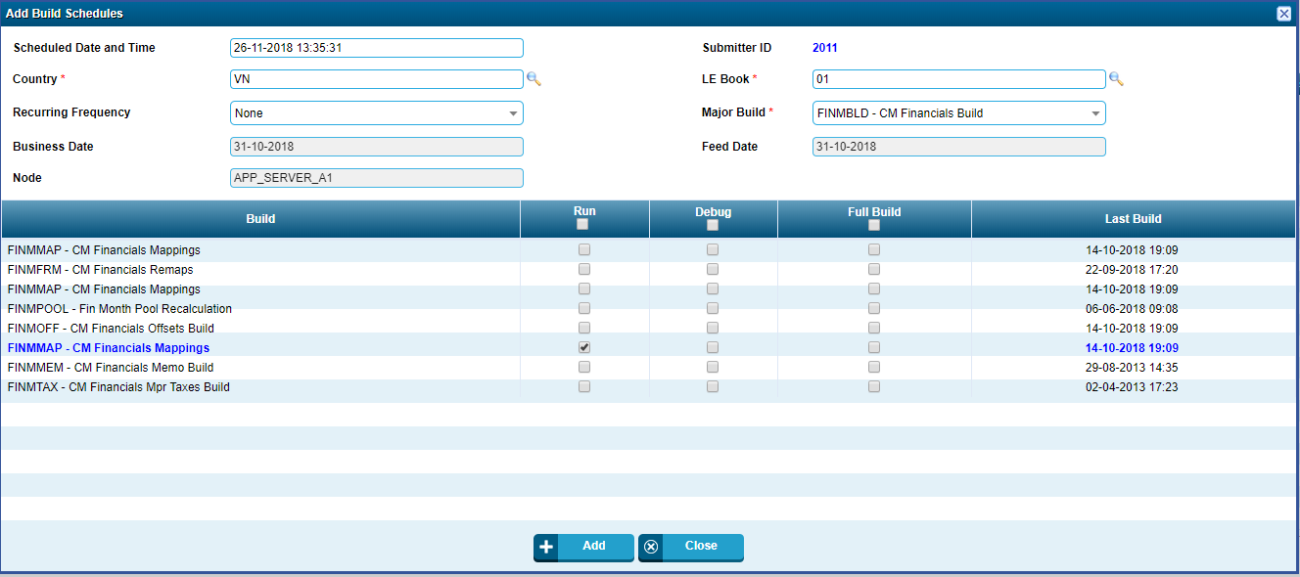
- FINHBLD – FINHMAP
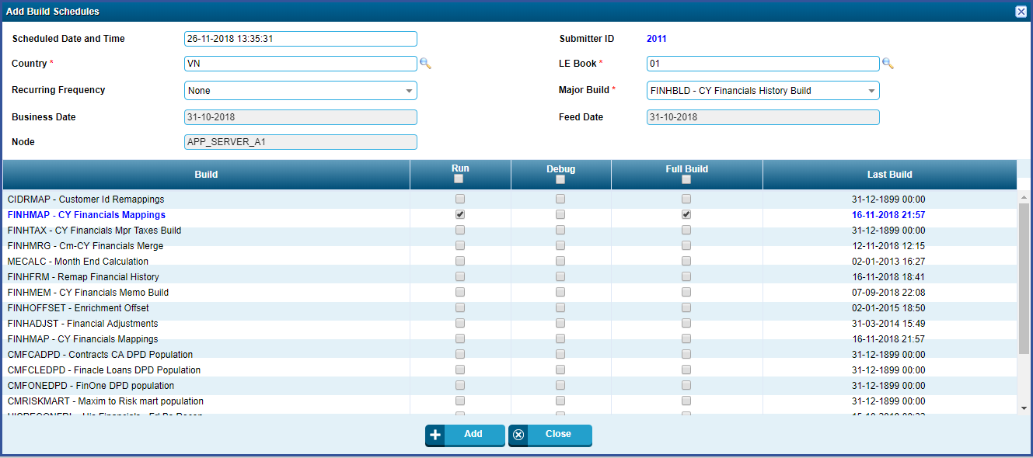
- MGTBLD – MGTAMRG
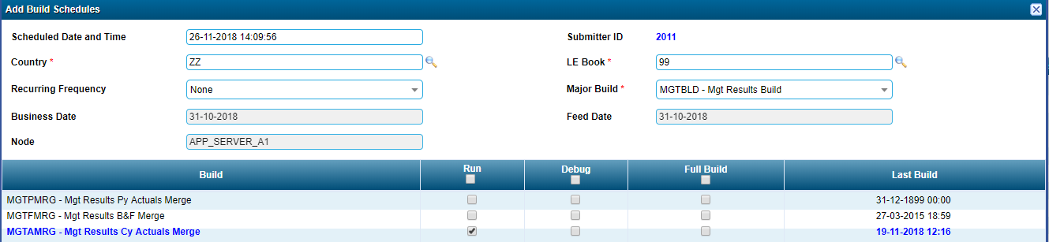
Scripts to Monitor EOD
- To check unprocessed ETL module for current business day.
Select * From Vision_Feed_Controls_Loop Where Completed_Flag !='C'
To check ETL log,navigate path in DB Server as designated in oracle directories.
/U01/App/Vision/Feedslogs/
After ETL completion,
- Check updated vision date to begin EOD process.
select * from vision_business_day
- Find logs in application server.
/vision/app/buildlogs
If Plug records value greater then >= 1 , then contact support team.

Findplug:13:09:34 Total Plug Records Processed [Final] < 2127>
Findplug:13:09:34 Total Plug Records Skipped [Final] < 0>
Findplug:13:09:34 Total Fin Dly Header Inserted < 0>
Findplug:13:09:34 Total Fin Dly Header Updated < 0>
Findplug:13:09:34 Total Fin Dly Balance Inserted < 0>
Findplug:13:09:34 Total Fin Dly Balance Updated < 6>
Or to double check, run following query,
Select *
From
Fin_Dly_Headers T1, Fin_Dly_Balances T2
Where T1.Country =T2.Country
And T1.Le_Book =T2.Le_Book
And T1.Year_Month =T2.Year_Month
And T1.Sequence_Fd =T2.Sequence_Fd
And T1.Country ='VN'
And T1.Le_Book ='01'
And T1.Year_Month =201811 -- change based on the business month
And Record_Type !=9999
And Bal_Type =51
And Source_Id =993
And ( Balance_01 !=0 Or
Balance_02 !=0 Or
Balance_03 !=0 Or
Balance_04 !=0 Or
Balance_05 !=0 Or
Balance_06 !=0 Or
Balance_07 !=0 Or
Balance_08 !=0 Or
Balance_09 !=0 Or
Balance_10 !=0 Or
Balance_11 !=0 Or
Balance_12 !=0 Or
Balance_13 !=0 Or
Balance_14 !=0 Or
Balance_15 !=0 Or
Balance_16 !=0 Or
Balance_17 !=0 Or
Balance_18 !=0 Or
Balance_19 !=0 Or
Balance_20 !=0 Or
Balance_21 !=0 Or
Balance_22 !=0 Or
Balance_23 !=0 Or
Balance_24 !=0 Or
Balance_25 !=0 Or
Balance_26 !=0 Or
Balance_27 !=0 Or
Balance_28 !=0 Or
Balance_29 !=0 Or
Balance_30 !=0 Or
Balance_31 !=0 )

- Vision also generates a reconciliation file in app server.
/Vision/App/Recon/Glreconfinagg_Vn01_25-Nov-2018.
To Rerun ETL for the same after finishing Vision EOD or missing data during ETL.
- Check last business date backup available in vision DB, backup tables are followed by date stamp.
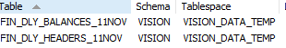
Ie. Above tables has 2 months backup, we need to delete our financial data for 2 months(current month and previous month) because of backdated transactions if correction is going to be on first 10days for current month else only delete current month.
To proceed futher..
- Delete From Curreny_Feed_Stg Where Feed_Date =<date to rerun>
- Update Vision_Feed_Controls_Loop Set Current_Business_Date= Previous Date, Date_Last_Run =Previous Date,Completed_Flag ='C',Manual_Date =<date to rerun>
- Update Vision_Business_Date Set Business_Date =<date to rerun - 1> ( Previous EOD Date)
- If ETL date is less than 11th of the current month then we need to execute as below.
DELETE FROM FIN_DLY_HEADERS WHERE COUNTRY ='VN' AND LE_BOOK ='01' AND YEAR_MONTH >= YYYYMM-1 (ie. 201811-1) ;-- THESE DATE WILL CHANGE BASED ONETL DATE
DELETE FROM FIN_DLY_BALANCES WHERE COUNTRY ='VN' AND LE_BOOK ='01' AND YEAR_MONTH >= YYYYMM-1 (ie. 201811-1) ;-- THESE DATE WILL CHANGE BASED ONETL DATE
DELETE FROM FIN_DLY_AUDIT WHERE COUNTRY ='VN' AND LE_BOOK ='01' AND YEAR_MONTH >= YYYYMM (ie. 201811 ) ; -- THESE DATE WILL CHANGE BASED ON ETL DATE
DELETE FROM FINANCIAL_FEED_STG WHERE COUNTRY ='VN' AND LE_BOOK ='01' AND FEED_DATE ='DD-MON-RRRR' ;
DELETE FROM TRANS_COUNT_FEED_STG WHERE COUNTRY ='VN' AND LE_BOOK ='01' AND FEED_DATE ='DD-MON-RRRR' ;
DELETE FROM FIN_DLY_TRANS_COUNT WHERE COUNTRY ='VN' AND LE_BOOK ='01' AND FEED_DATE ='DD-MON-RRRR';
INSERT INTO FIN_DLY_HEADERS SELECT * FROM FIN_DLY_HEADERS_DDMON_01 ; (EX 24NOV_01)
INSERT INTO FIN_DLY_BALANCES SELECT * FROM FIN_DLY_BALANCES_DDMON_01 (EX 24NOV_01)
- Call ETL script (.sh)
/Vision/App/Scripts/Visiondlyfeedcronloop.Sh
- Run FINDMAP Full Build manually.
- If ETL date is greater than 11th of the current month then we need to execute as below
Delete From Fin_Dly_Headers Where Country 'VN' And Le_Book ='01' And Year_Month = <Current Business Month>
Delete From Fin_Dly_Balances Where Country 'VN' And Le_Book ='01' And Year_Month = <Current Business Month>
Delete From Fin_Dly_Audit Where Country 'VN' And Le_Book ='01' And Year_Month = <Current Business Month>
Delete From Financial_Feed_Stg Where Country ='VN' And Le_Book ='01' And Feedd_Ate =' ETL DATE'
Delete From Trans_Count_Feed_Stg Where Country ='VN' And Le_Book ='01' And Feedd_Ate =' ETL DATE'
Delete From Fin_Dly_Trans_Count Where Country ='VN' And Le_Book ='01' And Feedd_Ate =' ETL DATE'

Insert Into Fin_Dly_Headers Select * From Fin_Dly_Headers_12Nov_01 Where Country 'VN' And Le_Book ='01' And Year_Month = 201811 -- these Date will change based onETL Date

Insert Into Fin_Dly_Balances Select * From Fin_Dly_Balances_12Nov_01 Where Country 'VN' And Le_Book ='01' And Year_Month = 201811 -- these Date will change based onETL Date
- Call ETL script (.sh)
/Vision/App/Scripts/Visiondlyfeedcronloop.Sh
- Run FINDMAP Full Build manually.

